**Textbook link**

This video corresponds to the textbook section on [Overview of Git](https://rafalab.github.io/dsbook/git.html#git-overview).

**Key points**

* In terminal: configure git

git config --global user.name "Your Name"

git config --global user.email "your@email.com"

* In RStudio, create project > Version control > Git
* Git pane: status symbols and color
* Git actions:

1. **pull**: pull changes from remote repo (if you are in collaboration with others)
2. **add**: stage files for commit; click on stage box under git pane
3. **commit**: commit to the local repo; click on "commit" button under git pane; add a commit message
4. **push**: push to the remote repo on Github

* .gitignore file: details check <https://git-scm.com/docs/gitignore>

**Section 2 Overview**

Bookmark this page

The Unix section discusses the basics of managing your filesystem from the terminal with Unix commands such as mv and rm.

There is a two-part graded comprehension check at the end of the section. Part 2 is only available to Verified learners.

If you get stuck, we encourage you to search the discussion boards for the answer to your issue or ask us for help!

Below, you will find a summary of Unix commands that will be covered in this section and the Advanced Unix section. The examples here and in videos refer to this hypothetical file system. You can download a [copy of the image](http://courses.edx.org/asset-v1:HarvardX+PH125.5x+1T2018+type@asset+block@data_science_1_rev.png).

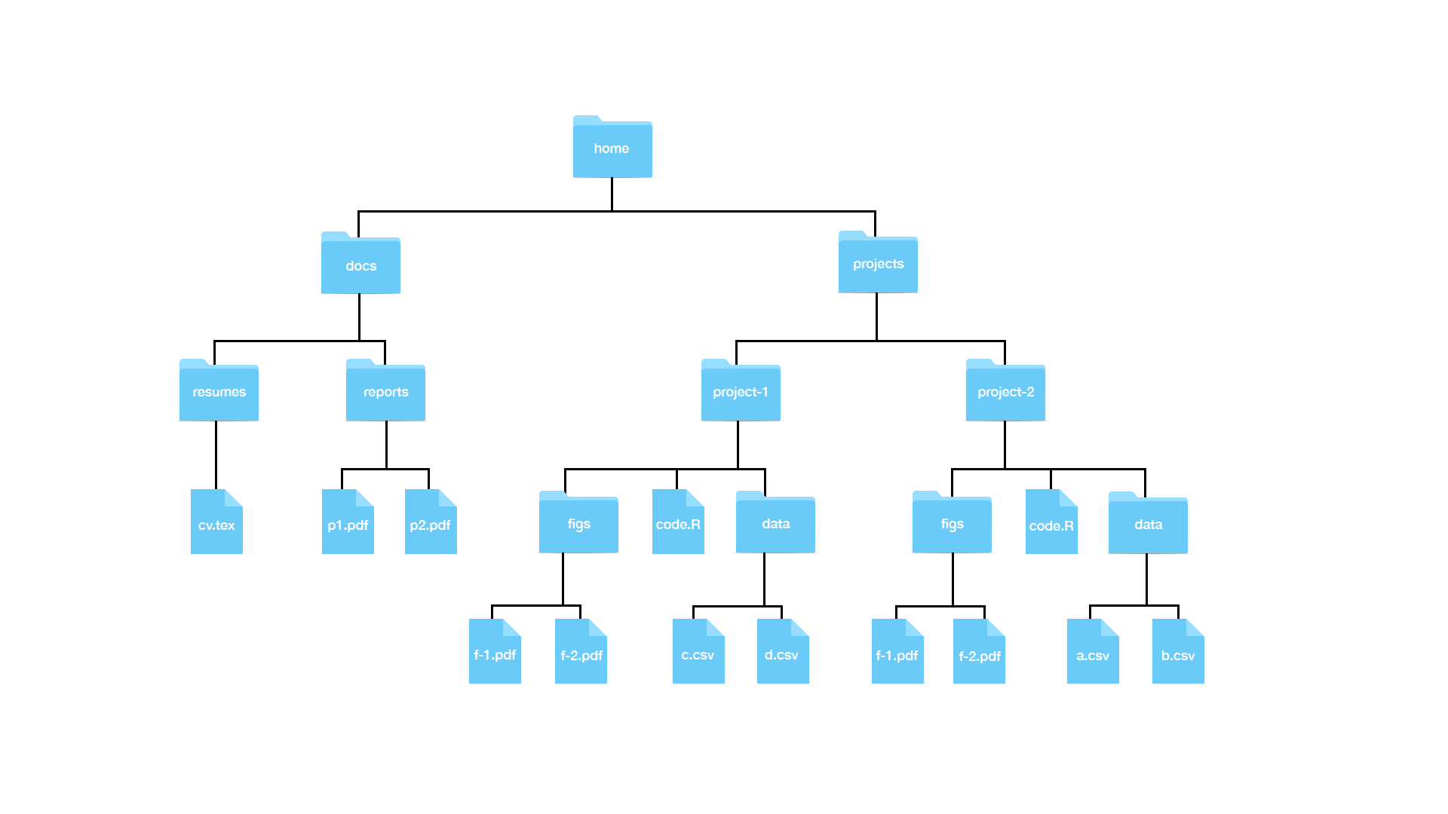

**Useful Unix Commands**

| **Command** | **Description** | **Examples** |
| --- | --- | --- |
| ls | List directory content |  |
| mkdir *dir* | Make a directory | mkdir projects –make the directory projects  mkdir docs –make the directory docs  mkdir junk –make the directory junk |
| rmdir *dir* | Remove a directory (directory must be empty; otherwise use “rm”) | rmdir junk –remove the directory junk |
| cd *dir* | Change directory | cd /projects – move to the projectsdirectory (an absolute path)  cd projects – move to the projectsdirectory, assuming we are already in the home directory (a relative path) |
| cd .. | Go up one directory to the parent directory | cd ../.. – move up two parent directories from our current directory |
| cd ~ | Go to the home directory |  |
| cd - | Go to whatever directory you just left |  |
| pwd | Print the present working directory |  |
| Tab key | Autocomplete | cd d + tab – autocompletes to docs if it is the only directory that begins with d; or list the different options. |
| mv *file1 file2* | Move or rename files  *Warning –this is permanent, and you will not get a warning message if you are overwriting files.* | mv ~/docs/resumes/cv.tex ~/docs/reports/ –move the cv.tex file from the resume folder to the reports folder  mv cv.tex resume.tex – rename cv.texto resume.tex  mv ~/docs/resumes ~ /docs/reports/- move the resume folder into the reports folder |
| cp *file1 file2* | Copy file1 to file2 | cp ~ ~/docs/reports/ – make a copy of the cv.tex file from the resume folder in the reports folder |
| rm *file* | Delete file  *Warning – this is permanent! You cannot retrieve files from the recycling bin!* | rm ~/docs/resumes/cv.tex – delete the file cv.tex |
| less *file* | View file | less ~/docs/resumes/cv.tex –open cv.tex in the less text viewer |
| rm -r *dir* | Remove recursively all folders in directory *dir* and the directory itself. |  |
| ls -a | List all directory content, including hidden files |  |
| ls -l | List all directory content in long form (including permissions, size and date) |  |
| ls -t | List all directory content in chronological order | ls -lart – show more information for all files in reverse chronological order for your current directory |
| man *command* | Show the manual for the command. Note – this does not work for GitBash | man ls – show the manual instructions for the command ls. |
| help | Show the manual for the command in GitBash | ls --help – show help instructions for the command ls |
| *command1*| *command2* | Pipe the results of command 1 to command 2 | man ls | less – show the help instructions for the command ls in the less viewer |
| * (wildcard) |  | ls *.html –list all the files ending in html in your current directory  rm *.html – remove all files ending in html in your current directory |
| ? (any character) |  | rm file.???.html – remove all files whose names follow the pattern; eg file-001.html, file-002.html etc.  rm file.???.* – remove all files whose names follow the pattern regardless of their extension; eg file-001.html, file-002.csv, file-any.R, etc. |
| $*var* | >$ identifies a variable | echo $HOME – print your home directory  echo $SHELL – print your shell name |
| export *val=value* | Change the value of the variable *val*(Bash shell specific) |  |
| open *file*(mac)*file*(windows) | Opens a file or program | open Report.Rmd – open Report.Rmd in RStudio |

**Absolute path vs. relative path**

A full path specifies the location of a file from the root directory. It is independent of your present directory, and must begin with either a “/” or a “~”. In this example, the full path to our “project-1” file is:

/home/projects/project-1

A relative path is the path relative to your present working directory. If our present working directory is the “projects” folder, then the relative path to our “project-1” file is simply:

project-1

**Path shortcuts**

One period “.” is your current working directory

Two periods “..” is the parent directory (up one from your present working directory)

A tilde   “~” is your home directory.

**More path examples**

1.     Your current working directory is ~/projects and you want to move to the figs directory in the project-1 folder

* Solution 2: cd ~/projects/project-1/figs (absolute)
* Solution 2:  cd project-1/figs (relative)

2.     Your current working directory is ~/projects and you want to move to the reports folder in the docs directory

* Solution 1: cd ~/dos/reports (absolute)
* Solution 2: cd ../docs/reports (relative)

3.     Your current working directory is ~/projects/project-1/figs and you want to move to the project-2 folder in the projectsdirectory.

* Solution 1: cd ~/projects/project-2 (absolute)
* Solution 2: cd ../../project-2 (relative)